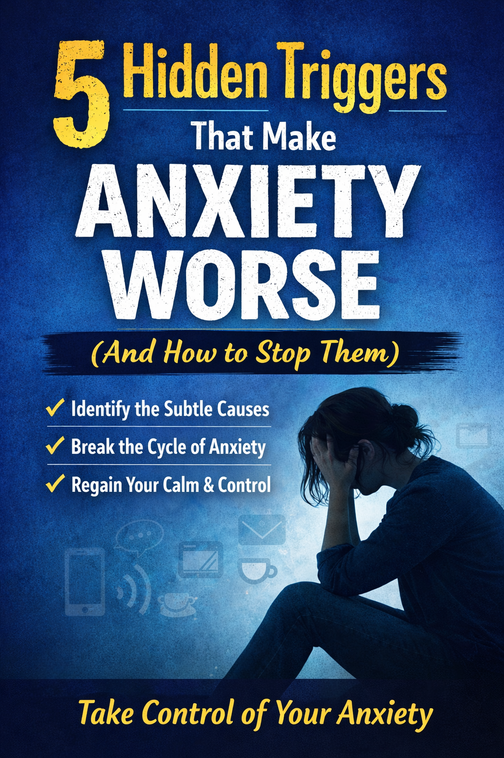
Anxiety doesn’t always come from obvious sources like stress, deadlines, or major life problems. In fact, many people unknowingly make their anxiety worse through subtle daily habits and environmental triggers.
The frustrating part? These triggers often hide in plain sight.
The good news is that once you recognize them, they are surprisingly easy to manage.
Below are five hidden triggers that silently increase anxiety — and practical ways to stop them before they take control.

1. Constant Information Overload
The Trigger
We live in a world of endless notifications, news alerts, emails, and social media updates. While staying informed can be helpful, constant information overload keeps the brain in a state of alert.
Your nervous system begins to treat everything as urgent — even when it’s not.
This leads to:
- Mental fatigue
- Increased worry
- Difficulty relaxing
How to Stop It
Create intentional limits around information consumption.
Try this:
• Turn off non-essential notifications
• Limit news checking to once or twice per day
• Schedule “no phone” periods during the evening
Even 30 minutes of screen-free time can help reset your nervous system.

2. Poor Sleep Habits
The Trigger
Sleep and anxiety have a two-way relationship.
Lack of sleep increases anxiety levels, and anxiety makes it harder to sleep.
When you consistently sleep poorly, the brain becomes more reactive and less capable of regulating emotions.
You may notice:
- Racing thoughts at night
- Feeling on edge during the day
- Increased irritability
How to Stop It
Improve your sleep routine with a few simple changes:
• Keep a consistent bedtime
• Avoid screens 60 minutes before sleep
• Reduce caffeine after early afternoon
Good sleep doesn’t just reduce fatigue — it directly stabilizes the brain’s anxiety response.

3. Too Much Caffeine
The Trigger
Caffeine stimulates the nervous system by increasing adrenaline and cortisol — the same chemicals involved in the fight-or-flight response.
For people prone to anxiety, caffeine can amplify symptoms such as:
- Rapid heart rate
- Jitters
- Restlessness
- Panic-like sensations
Many people don’t realize their daily coffee habit may be intensifying their anxiety.
How to Stop It
You don’t necessarily need to quit caffeine entirely.
Instead:
• Limit caffeine to the morning
• Reduce intake gradually
• Replace later drinks with herbal tea or water
Many people notice a dramatic improvement in anxiety after reducing caffeine.

4. Negative Thought Loops
The Trigger
Anxiety often feeds on automatic negative thoughts.
These thoughts happen quickly and feel believable, even when they aren’t accurate.
Common examples include:
- “Something bad is going to happen.”
- “I’m not good enough.”
- “Everyone is judging me.”
These mental loops reinforce anxiety and make problems feel bigger than they actually are.
How to Stop It
Practice thought awareness and reframing.
Try asking yourself:
• “Is this thought actually true?”
• “What evidence do I have for it?”
• “What would I tell a friend in this situation?”
Replacing automatic thoughts with more balanced ones helps retrain the brain over time.

5. Avoidance Behavior
The Trigger
When something makes us anxious, our instinct is to avoid it.
While avoidance provides short-term relief, it reinforces anxiety in the long run.
Your brain learns:
“That situation must be dangerous because I keep avoiding it.”
Over time, the list of avoided situations grows.
How to Stop It
Gradual exposure is the most effective strategy.
Start small.
If a situation makes you anxious:
- Break it into smaller steps
- Face the easiest step first
- Repeat until it feels manageable
Each small success teaches the brain that the situation is not actually dangerous.
Final Thoughts
Anxiety isn’t always caused by big life problems.
Often, it’s the small, repeated triggers in everyday life that quietly keep the nervous system stuck in overdrive.
By recognizing and adjusting these habits, you can significantly reduce anxiety and regain a sense of control.
Start with one small change today. Over time, these changes build a healthier, calmer mind.
Learn More at TheAntiAnxietyFormula.com

